**PROJECT**

**PHASE – 3**

CSE 5330 -005 **DATABASE SYSTEMS-I**

**Prof: Bhanu Jain**

**GTA: Rana, Sanjivni**

**Team-13**

**Sai Krishna Prateek Nama 1001880903**

**Shubash Muniyappa 1001915563**

Q1. Display the ITEM details based on any one of the following: item name or Item Id.

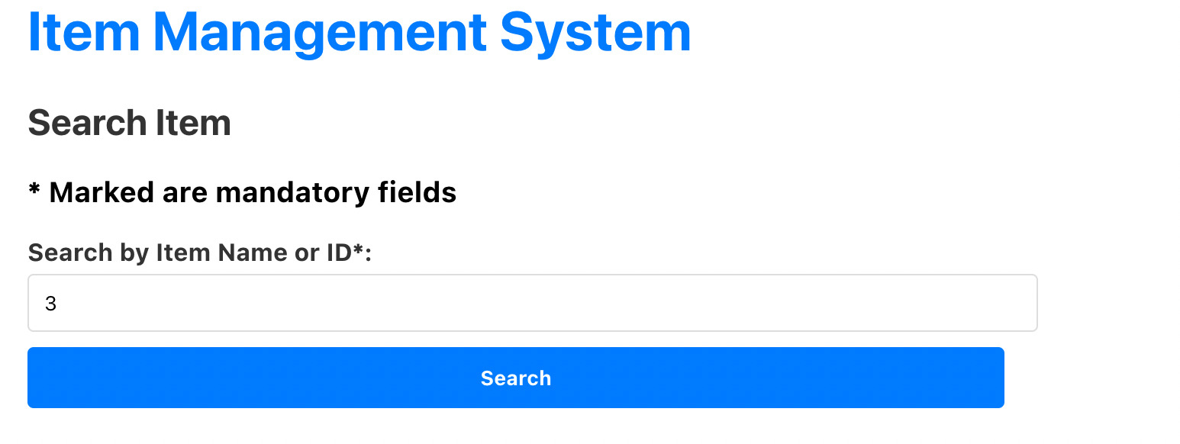

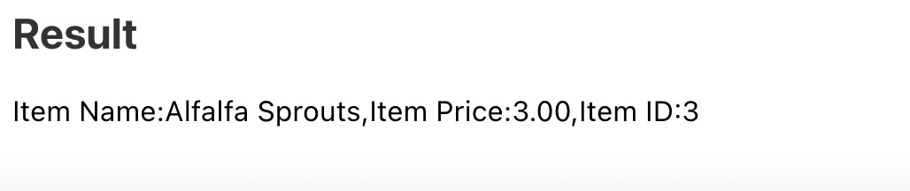

Q2. Insert a new item “Carot Sprouts” in the Arlington Sprouts database using the web interface you created.

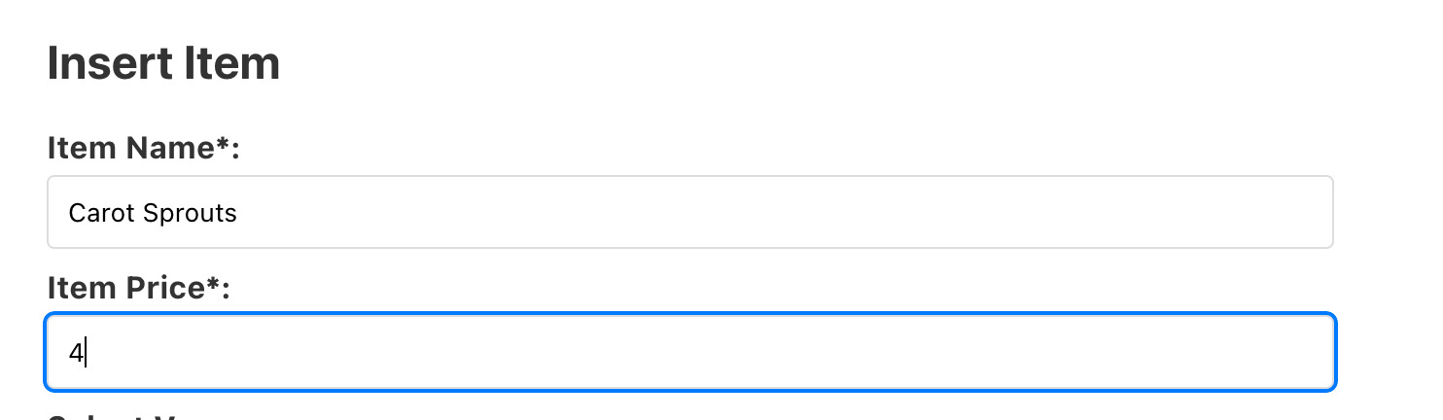



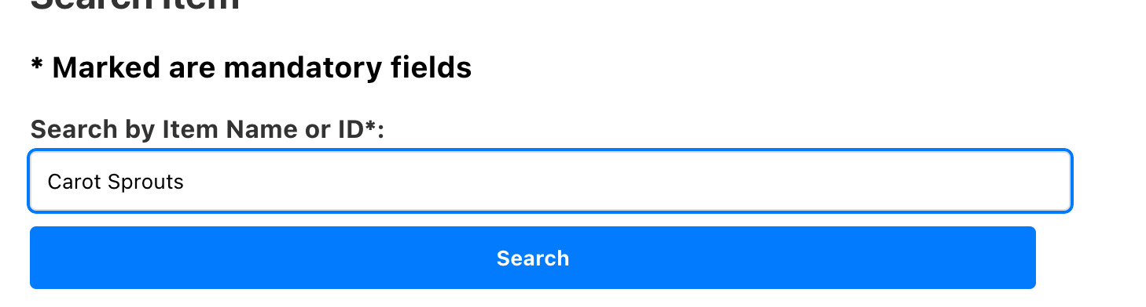

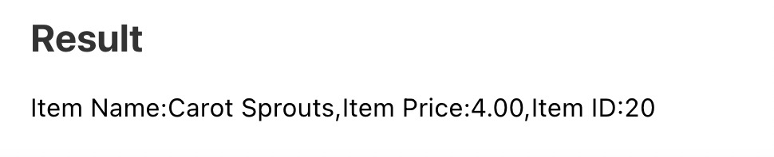

Q3. Update the item record that you just added “Carot Sprouts” to “Carrot Sprouts” using the web interface you created.

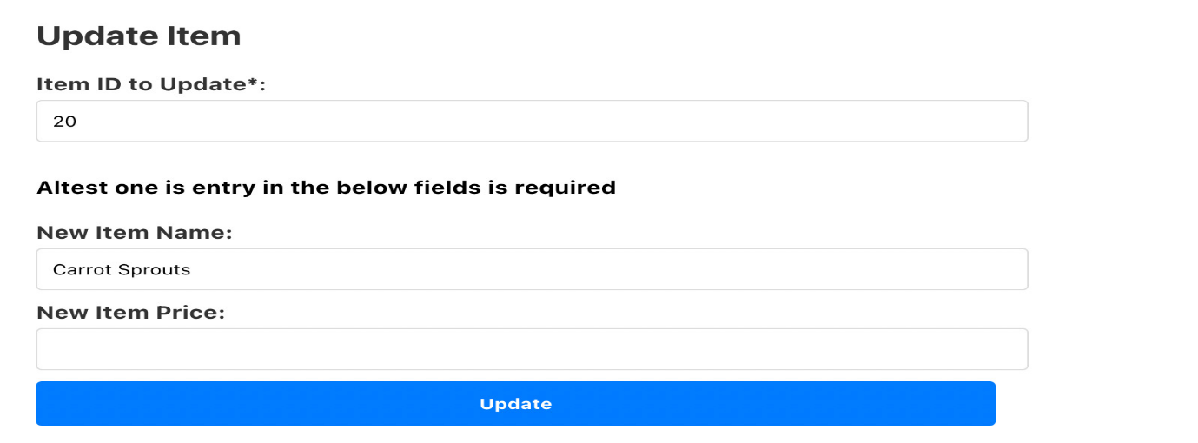

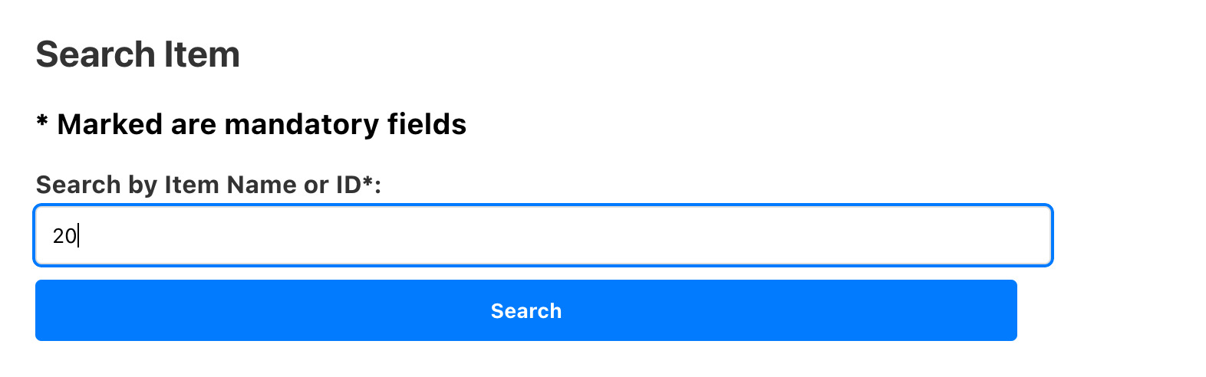

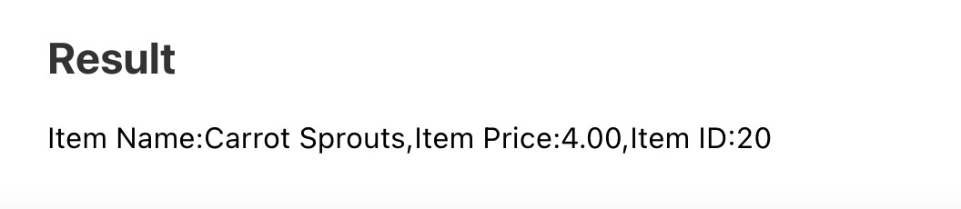

Q4. Delete the item record “Carrot Sprouts” that you just added using the web interface you created

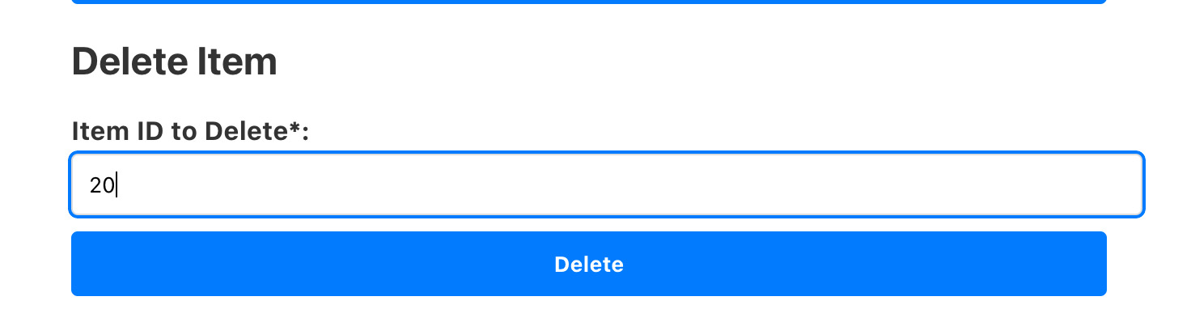

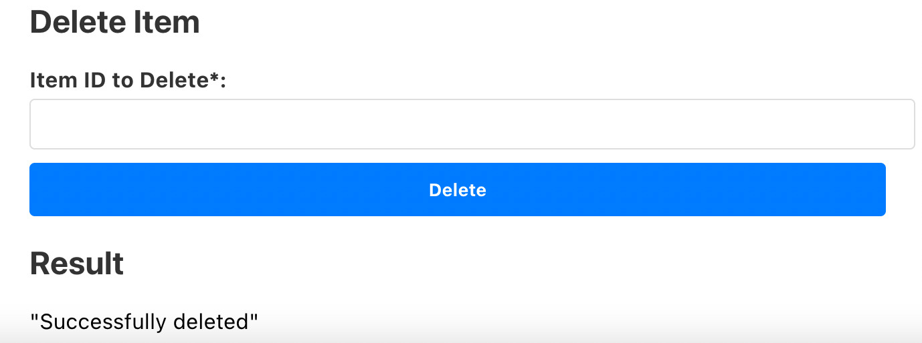

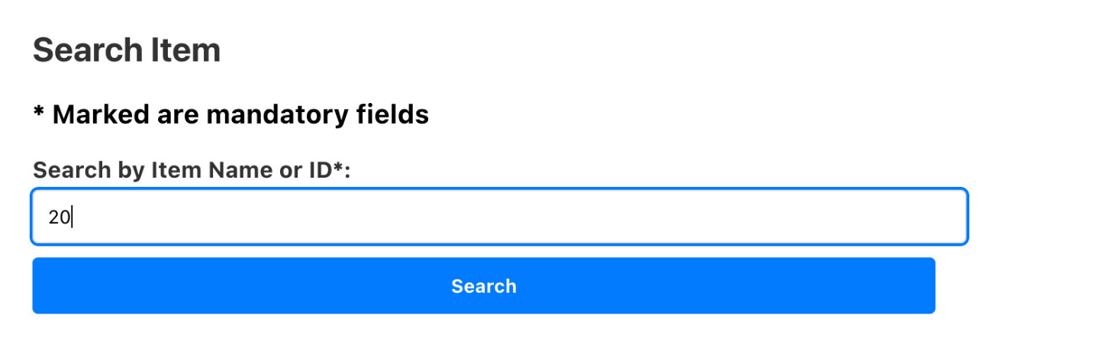



**View Based Questions**

Create a view ItemView that displays a list of records where each record is comprised of the itemId as iId, item name as  
ItemName, the number of boxes of the item sold as NoOfBoxes, the item price as ItemPrice, the revenue generated by  
each item as ItemRevenue, and the number of customers as ItemCustomers who bought the item boxes at any of the  
Arlington Sprouts stores.

DROP VIEW IF EXISTS ItemView;

CREATE VIEW ItemView (iId, ItemName, NoOfBoxes, ItemPrice,ItemRevenue, ItemCustomers)

AS SELECT I.iId, I.Iname, SUM(OI.Icount), I.Sprice, SUM(I.Sprice* OI.Icount), C.Cname FROM ITEM I, ORDERS O, CUSTOMER C, ORDER_ITEM OI

WHERE I.iId = OI.iId AND OI.oId = O.oId AND O.cId = C.cId

GROUP BY I.iId, I.Iname, I.Sprice;

Write an SQL query to display the contents of the view ItemView

SELECT iId, ItemName, NoOfBoxes, CONCAT('$.', ItemPrice) AS ItemPrice,CONCAT("$.", ItemRevenue) AS ItemRevenue, ItemCustomers FROM itemview;

QV1. Use the view ItemView to retrieve a list of records where each record is comprised of item Id, item name, the  
number of boxes of items sold, and the price of each box of the item for all items that cost more than $3.00 and that have  
been bought by customers.  
Column names:

SELECT iId, ItemName, NoOfBoxes, CONCAT("$.", ItemPrice)AS ItemPrice FROM itemView WHERE ItemPrice > 3 ORDER BY ItemPrice ASC;

QV2 Use the view ItemView to retrieve a list of records where each record is comprised of the item Name and the  
ItemRevenue for the item(s) that generated the minimum revenue in the database.

SELECT ItemName, ItemRevenue AS MinitemRevenue FROM ItemView WHERE ItemRevenue = (SELECT MIN(ItemRevenue) FROM itemview);

QV3 Use the view ItemView to generate the min, max and average revenue generated by all the items in the ItemView.

SELECT MIN(ItemRevenue) AS MinItemRevenue, MAX(ItemRevenue) AS MaxItemRevenue , AVG(ItemRevenue) AS AvgItemRevenue FROM ItemView;

QV4 Use the view ItemView to retrieve a list of records where each record is comprised of an item name along with the  
number of customers who bought it. Sort the list by the number of customers in descending order followed by item names  
in an ascending order.

SELECT ItemName, COUNT(ItemCustomers) AS ItemCustomers FROM ItemView GROUP BY ItemName ORDER BY ItemCustomers Desc, ITEMName ASC;

QV5 Use the view ItemView to retrieve the total revenue earned, the total number of boxes sold and the average revenue  
per box sold by Arlington Sprouts as stored in the database.  
  
SELECT CONCAT('$', SUM(ItemRevenue)) AS TotalRevenue, SUM(NoOfBoxes) AS TotalNumOfBoxes, CONCAT('$',AVG(ItemRevenue/NoOfBoxes)) AS 'AvgRevenue/Box' FROM ItemView;

**Contribution:**

Both Shubash Muniyappa and Sai Krishna Prateek contributed equally in each part of Interface development and querying the database on view.